Week 10
Problem Statement:
Given a string, s, consisting of alphabets and digits, find the frequency of each digit in the
given string.
Program:
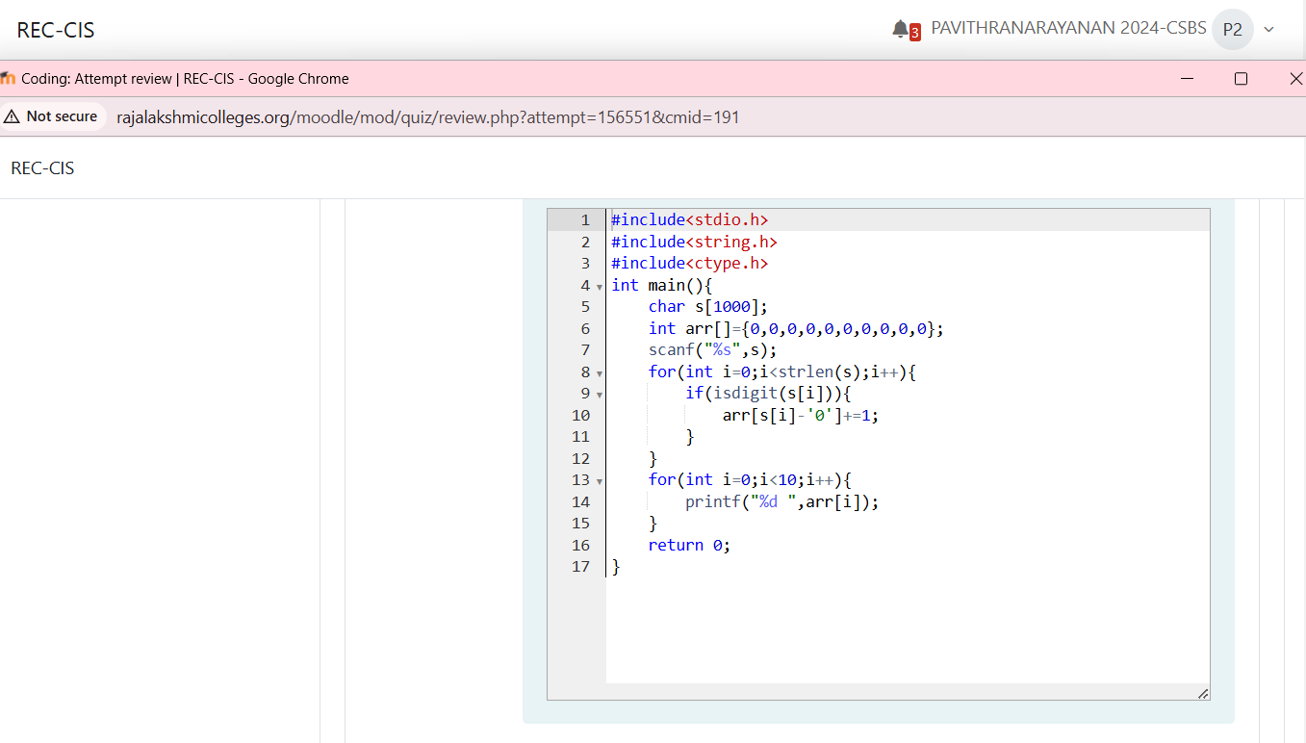
Output:
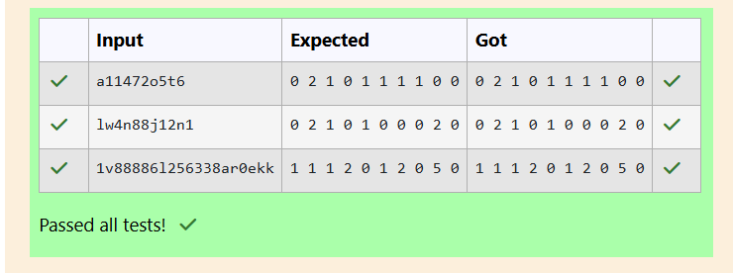
Problem Statement:
Today, Monk went for a walk in a garden. There are many trees in the garden and each
tree has an English alphabet on it. While Monk was walking, he noticed that all trees with
vowels on it are not in good state. He decided to take care of them. So, he asked you to tell
him the count of such trees in the garden.
Program:
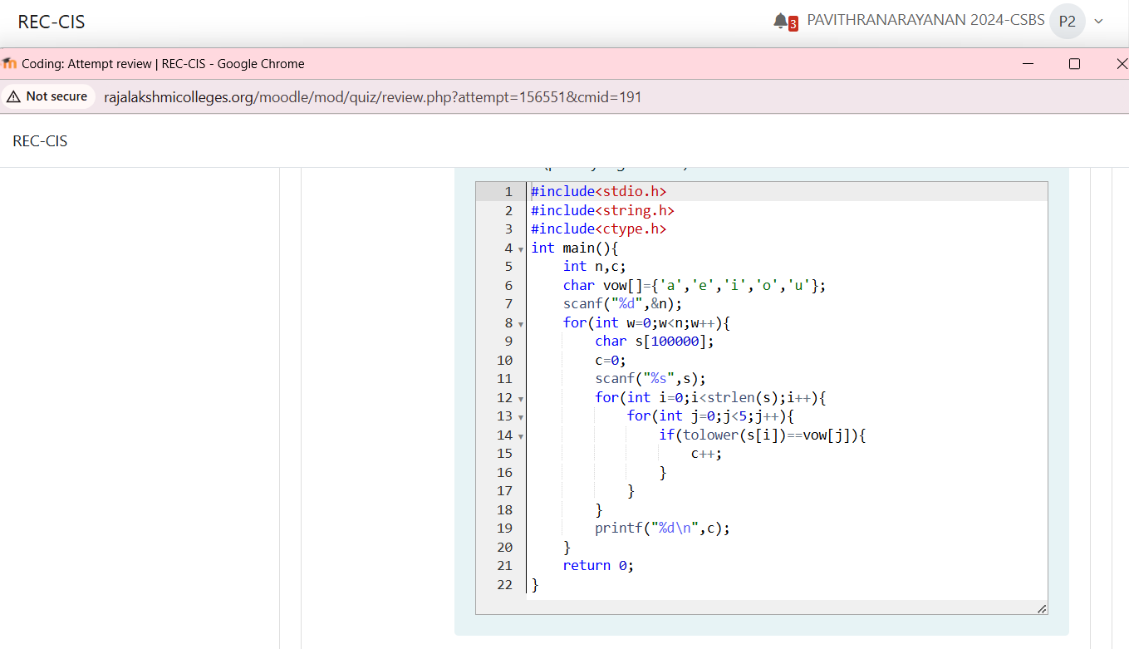
Output:
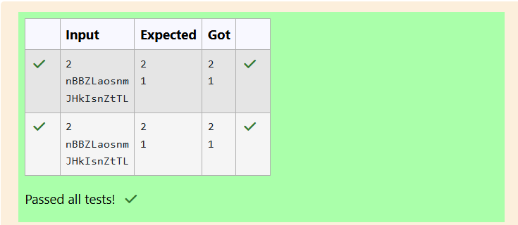
Problem Statement:
Given a sentence, s, print each word of the sentence in a new line.
Input Format
The first and only line contains a sentence, s.
Constraints
1 ≤ len(s) ≤ 1000
Output Format
Print each word of the sentence in a new line.
Program:
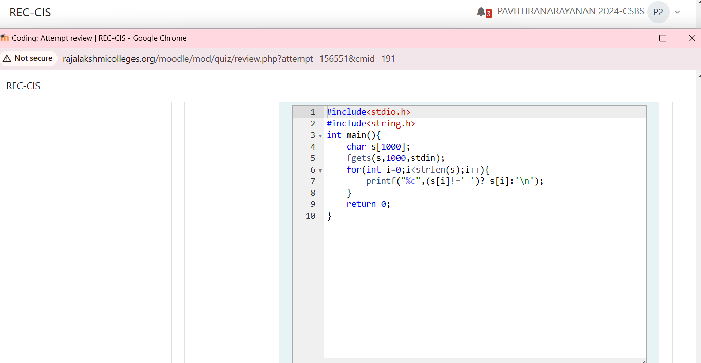
Output:
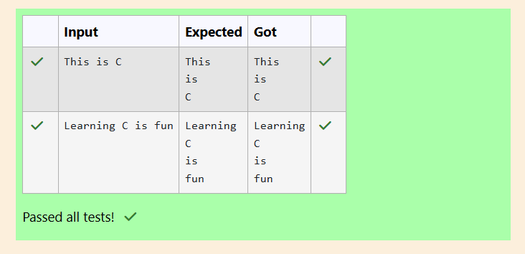
Problem Statement:
Input Format
You are given two strings, a and b, separated by a new line. Each string will consist of
lower-case Latin characters ('a'-'z').
Output Format
In the first line print two space-separated integers, representing the length of a and b
respectively.
In the second line print the string produced by concatenating a and b (a + b).
In the third line print two strings separated by a space, a' and b'. a' and b' are the same as
a and b, respectively, except that their first characters are swapped.
Program:
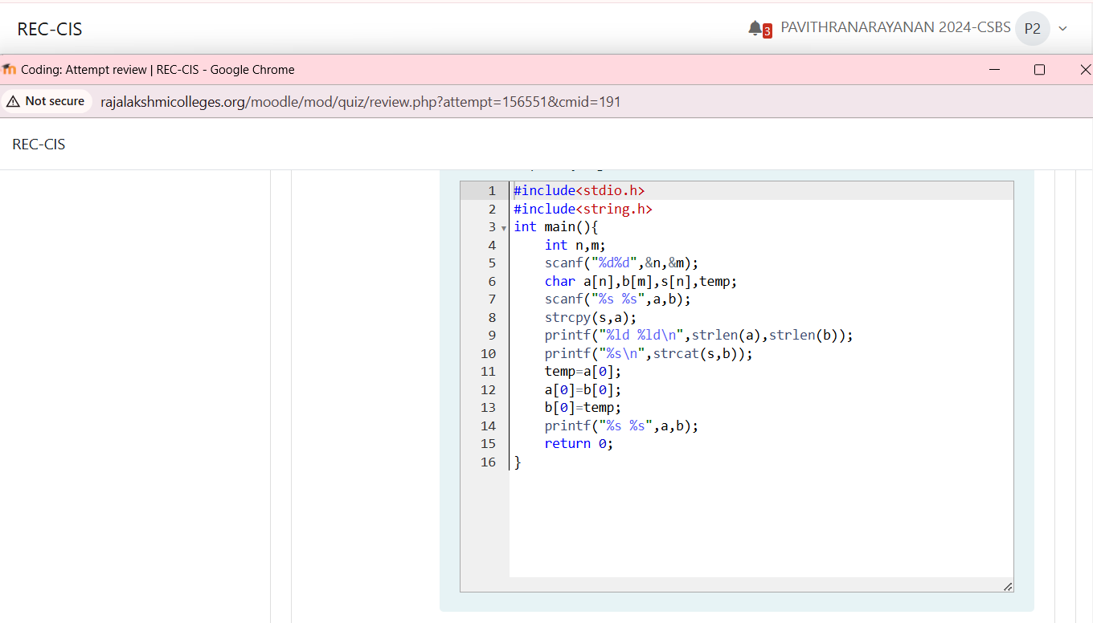
Output:
